Lab Plan – 6

Objective:
To develop a Flutter application that visually represents a xylophone with colorful bars and produces musical sounds when tapped.
For installations of dependencies visit: https://pub.dev/
Steps:
- Create a new Flutter project named xylophone_app.
- Create an appbar named as “Xylophone”
- Add dependency audioplayers: ^0.20.1 in the pubspec.yaml file.
- Add audio files (note1.wav to note7.wav) in an assets folder and declare them under the flutter: section of pubspec.yaml.
- Import package:
import 'package:audioplayers/audioplayers.dart';

- Create 7 buttons using TextButton widgets, each having:
  - A unique color
  - An onPressed() function that plays a corresponding sound.
- Use Expanded widgets so each button takes equal vertical space.
- Run the app and test that each button plays its assigned sound.

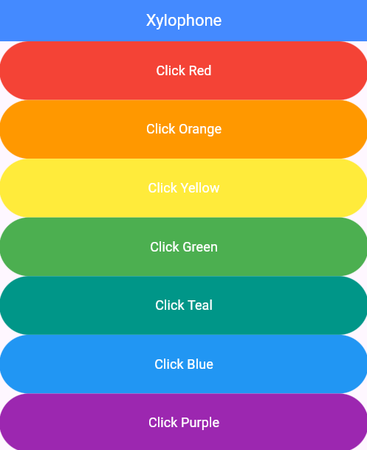

CODE:
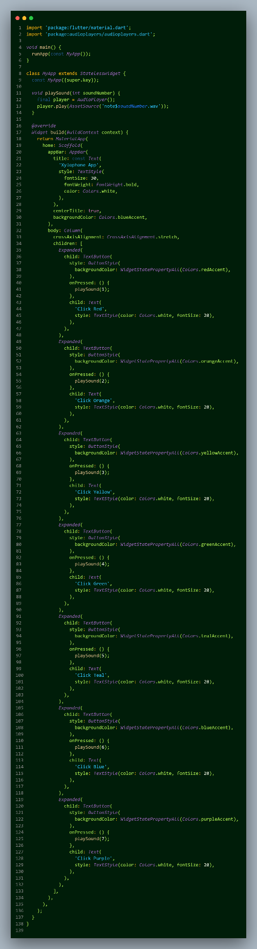
OUTPUT:
